Early Humans
  - Final project – Content/Evidence of learning, sources
Content
Note: Content on poster board was shortened and important words were bolded to make it easier for viewers to quickly see and understand the exhibit.

About the Species

Overview
Nicknamed "The Hobbits", Homo Floresiensis means Flores Human, because they have so far only been found on the Island of Flores, Indonesia. They got their nickname from their size - they were only ever 106.68 centimetres (3 feet and 6 inches) tall, just over a metre! Their size helped them survive with limited resources.

Appearance
H. floresiensis individuals stood approximately 3 feet 6 inches tall, had tiny brains, large teeth for their small size, shrugged-forward shoulders, no chins, receding foreheads, and relatively large feet due to their short legs. Despite their small body and brain size, H. floresiensis made and used stone tools, hunted small elephants and large rodents, coped with predators such as giant Komodo dragons, and may have used fire. Their small bodies may have been a disadvantage against predators, but helped them survive with little resources.

Diet
H. floresiensis selectively hunted Stegodon (an extinct type of elephant) as hundreds of Stegodon bone fragments are found within H. floresiensis occupation layers and some of these Stegodon bones show butchery marks. Stegodon were small elephant-like creatures that lived on Flores.

Other
H. Floresiensis were able to survive isolated on a small island, which resulted in island dwarfism, which is "an evolutionary process that results from long-term isolation on a small island with limited food resources and a lack of predators" - Smithsonian Website. They were able to make stone tools and may have used fire.

About the Fossil
Liang Bua 1, or LB-1, is famous for being the most complete Homo Floresiensis fossil ever found. It was found in Liang Bua Cave, and since this hominin species was so small, they mistook it for a skeleton of a modern human child when archaeologists first found it. They had large, flat feet, as this model shows. They had a tiny skull with a small braincase, protruding brow ridges and no prominent chin. This is a model of a Homo Floresiensis left foot. Only some pieces of the foot were found at the dig site, the other bones were made by scientists using existing evidence to predict what the bones would have looked like.

Location
Fossil was found in Liang Bua Cave, aka. Hobbit Cave, a limestone cave in the island of Flores, an island in Indonesia.
During the 1950s and 60s, a Dutch priest named Father Theodor Verhoeven lived and worked on Flores at a Catholic Seminary. Verhoeven had a keen interest in archaeology and had studied it at university. While living on Flores, he identified dozens of archaeological sites and conducted excavations at many of these, including the now famous site of Liang Bua where the "hobbits" of human evolution were discovered (Homo floresiensis).
Scientists found that early humans arrived there at least 1 million years ago, but it’s not known how early humans got there as the nearest island is 9 km (6 mi) away across treacherous seas.
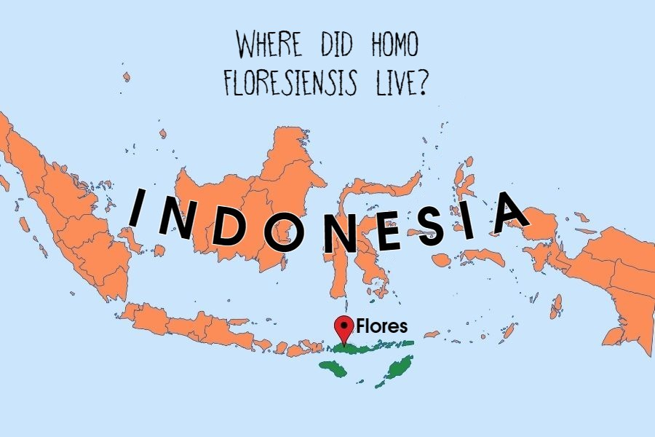
Stone tools were found in association with Stegodon remains in central Flores.
Custom-made picture of Flores, Indonesia

Discovery

Dig site
The dig site was limestone cave located in west central Flores. This cave, known as Liang Bua (which means "cool cave"). Liang Bua Cave is famous for the plentiful amount of Homo Floresiensis fossils, including LB-1, the most complete H. Floresiensis fossil to date.

Tools use by archaeologists
Archaeologists used tools like trowels, small picks, brushes, dustpans, shovels, large picks, and bulk scrappers for excavation.
The shovel and pick help loosen and scoop out soil, the small pick can be used for more detailed work. Brushes can be used to brush off rocks and clean uneven surfaces. Paintbrushes are used for the most delicate work, like carefully removing earth around the item being excavated. The most important tool is the trowel, used for a variety of things on site ranging from scraping a bulk to examining soil changes on a surface, or simply collecting dirt into a dustpan.

Time period
The fossils of LB-1 come from different levels and range in date from 100,000 to 60,000 years old. Being one of the most recent hominins, they started to exist at the time when the human brain size evolved, From 800,000–200,000 years ago. They died out during the Agricultural Revolution ("the Turning Point"), just before the Neanderthals, and Homo Sapiens remained the only humans left in the world, and took over.
Timeline PowerPoint included – printed and cut along the middle line.

Comparisons

H. Habilis
H. Floresiensis can be compared to Homo Habilis, meaning "handy human". They were the first human species to use stone tools. This enabled them to crack and smash bones to access the marrow inside that other animals left behind. They soon learned to make more sophisticated stone tools, enabling them to hunt for their food, just as H. Floresiensis hunted the Stegodon.

H. Erectus
H. Floresiensis can also be compared to Homo Erectus, the first human species to use fire. Fire enabled humans to cook, which releases the nutrients inside the food. Cooking also made food easy to digest and chew, which gave them more time for other activities, like thinking. H. Floresiensis also used fire for cooking.

H. Sapiens
Compared to Homo Sapiens, Homo Floresiensis were a lot smaller, just over half our height. They had large, flat feet, as my fossil model shows. They had a tiny skull with a small braincase, protruding brow ridges and no prominent chin. In fact, archaeologists thought it must be the skeleton of a modern human child when it was first discovered. These characteristics are similar to those of australopithecines, an ancient branch of hominins.
H. Floresiensis, being a later human species, were able to use these skills to their advantage and were able to survive on a small isolated island for 40 thousand years.
Homo Floresiensis fossils weren't too different from each other, since they lived for a short period of time.

Tools
Homo Floresiensis used stone tools such as simple flakes, points, perforators, blades and microblades, some of which we can find alongside Stegodon (a dwarf elephant-like animal) remains with butchery marks, indicating that they hunted these prehistoric animals.
H. Floresiensis may have used fire for cooking.
Sources
LB-1 | The Smithsonian Institution's Human Origins Program (si.edu)
Homo floresiensis | The Smithsonian Institution's Human Origins Program
Human Evolution Interactive Timeline | The Smithsonian Institution's Human Origins Program (si.edu)
Flores fossil discovery provides clues to 'hobbit' ancestors | Science | The Guardian
'Hobbit' human story gets a twist, thanks to thousands of rat bones (nationalgeographic.com)
Hobbit's Brain Size Holds Clues About Its Ancestor (nationalgeographic.com)
Homo floresiensis (bradshawfoundation.com)
Homo floresiensis - The Australian Museum
Homo floresiensis: the real-life 'hobbit'? | Natural History Museum (nhm.ac.uk)

